Mashup in Pega

Create one mashup from the channels and interfaces I created as the Login

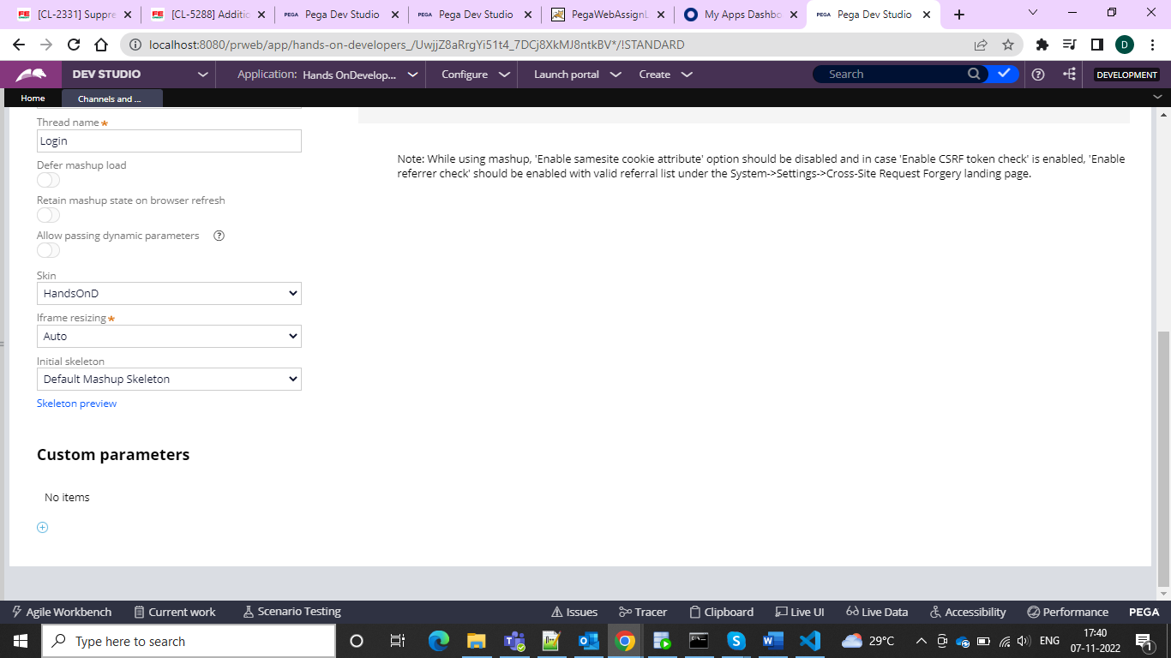



And now after this configuration generate the Mashup Code

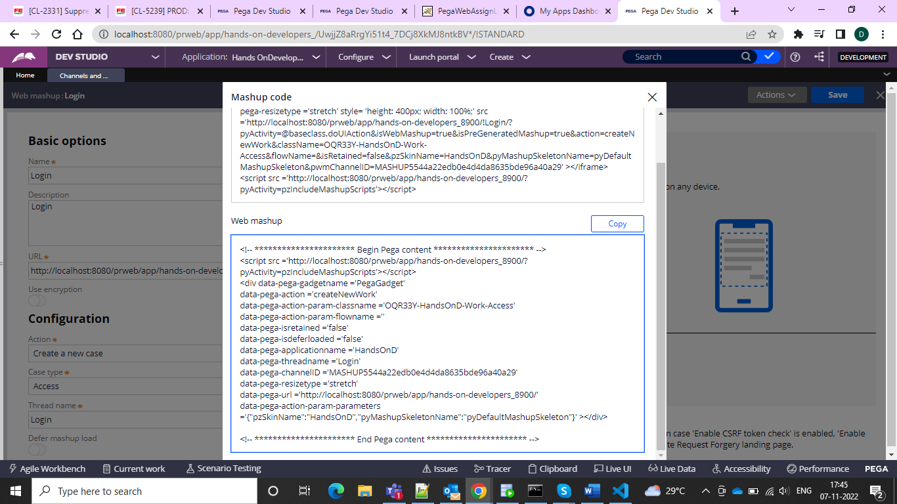

And then we can create HTML file in VisualStudio Code and then create HTML file with the html tags body and then paste the mashup code and save it as html file and then paste it inside the PRPC file under the tomcat >webapps > ROOT and inside this folder paste the html file and now login through the

Localhost:8080/yourfilename.html

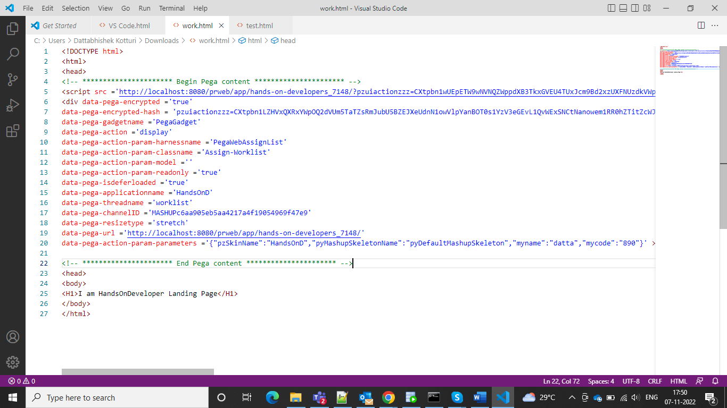

And then go for the

And boom the mashup is shown and then we can go for the execution in localhost

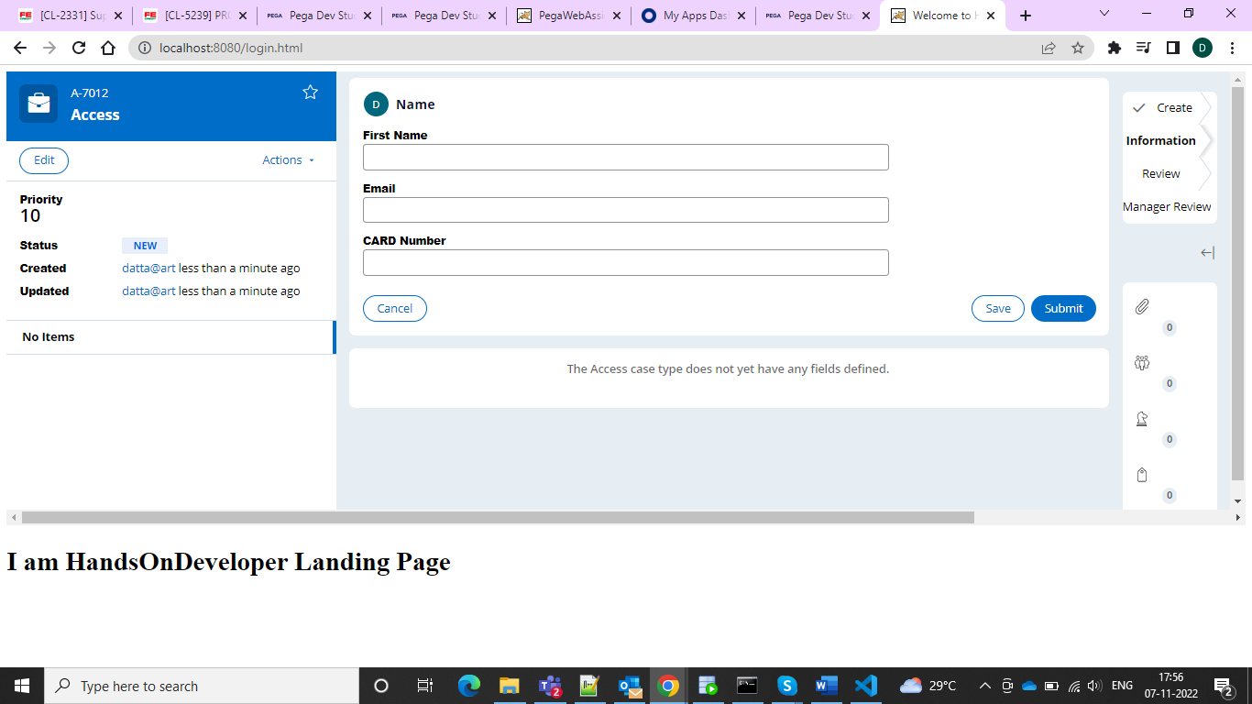

Under localhost we can do the changes in pega under one website

In order to interact between two mashups we need to add the 2 mashup codes In the html code and add extra script tag and change the gadget names

<script> var PegaGadgetA = { actionDefinitions: [ { action: "openAssignment", target: { type: "_gadget", name: "PegaGadgetB" } } ] }; </script>

For the first script use this where we are mentioning as to open assignment and interact with the 2 nd gadget

And for the second script

<script> var PegaGadgetB = { actionDefinitions: [ { action: "confirm", actionMapping: "refresh", target: { type: "_gadget", name: "PegaGadgetA" } } ] }; </script>

And then we are using this script to interact with the first gadget and both would load simultaneously.

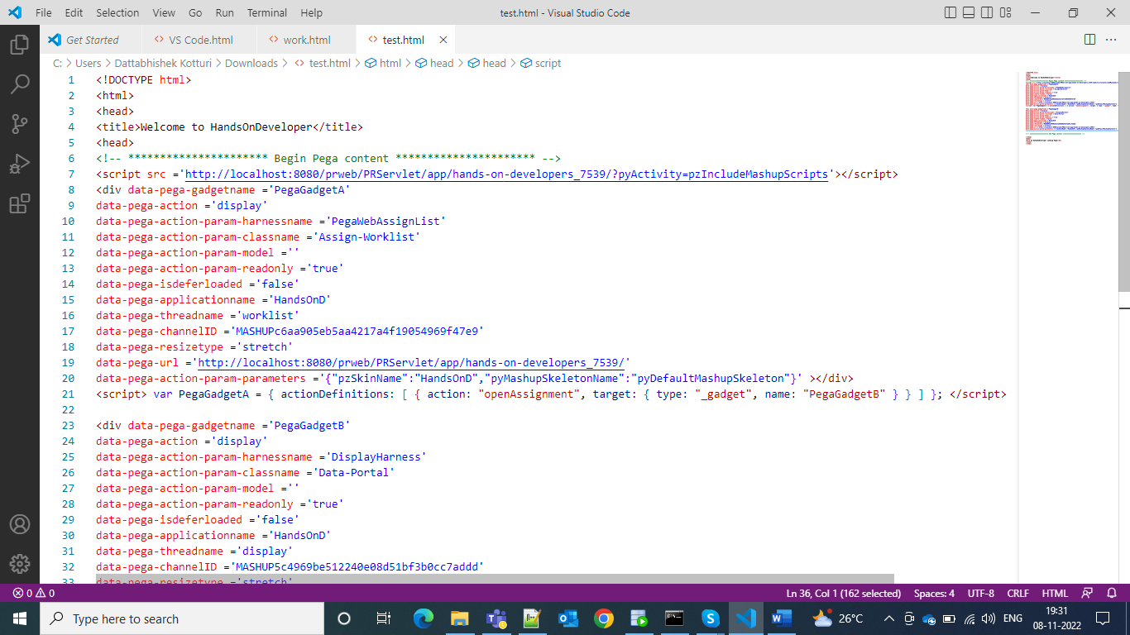

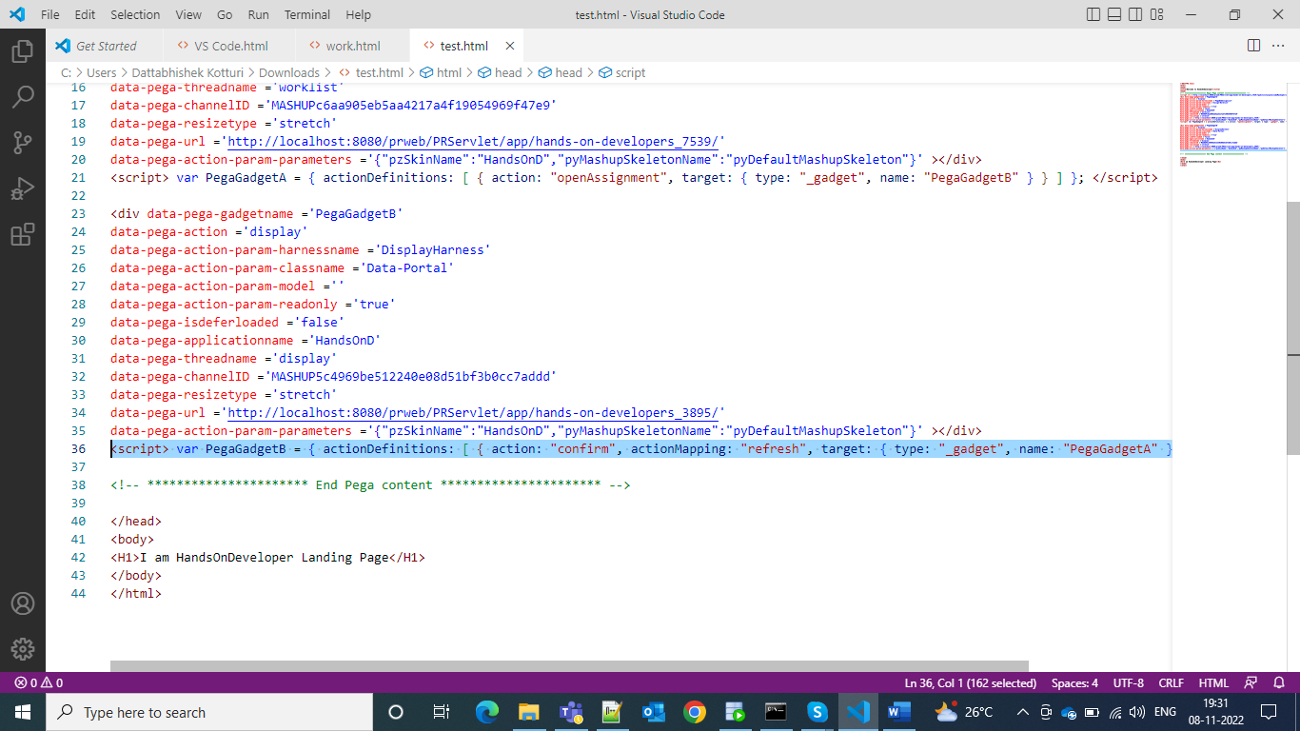

And then we can load our mashup in the page

